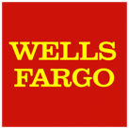
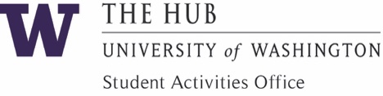

Wells Fargo Fund Application for Registered Student Organizations
Applications can only be submitted by 1 of the 5 RSO Officers starting on 10/1/20 for Fall Quarter Events and 11/16/20 for Winter Quarter Events. Applications for Spring Quarter TBD. Applications must be received at least 3 weeks prior to the event. The maximum grant an RSO may receive is $500 per academic year to be used to enrich campus culture, foster student empowerment, and enhance community impact.

Full RSO Name |  | SAO Adviser |  | Today’s Date

RSO Officer Name |  | UW Email |  | Phone

Event Name |  | Type of Event (i.e. Concert, BBQ, Fair, etc.)

Event Date(s) |  | Event Time(s)

Event Location |  | Event Purpose/Goal

Yes No |  | Yes No
Is Event a Fundraiser? |  | Will you donate money raised to an off-campus organization(s)? |  | If Yes, Organization(s) Name(s) (Attach separate sheet for more names)  If Yes, you must also attach the Charitable Fundraising Request Form.

Yes No |  | If Yes, list the organization names and itemized items on the Event Budget Planning Worksheet.
Will you be seeking financial co-sponsor(s)? |  | (See next question)

REQUIRED: Have you attached the Event Budget Planning Worksheet

listing all itemized program costs requested?
Yes No |  | TOTAL Amount Requested  (must not exceed $500.00)

Mandatory Requirements: Include the HUB & Wells Fargo logos (found in RSO Community) on all physical and electronic materials. Provide SAO with a physical and/or electronic copy of your program/flyer, along with quality photos from your event.
You must also complete the post-event survey that will be sent to you in confirmation emails.

I certify that I have read and will abide by the policies for the Wells Fargo Fund for Registered Student Organizations.

RSO Officer Name & UW Email |  | Date

Questions? Contact SAO: 206-543-2380 | saofunds@uw.edu | HUB 232

SAO Use Only | SAO Adviser Reviewed: |  |  | FINAL Approved Amount:
 | SAO Approval: |  |  | Project Code:

